ELECTRONIC COMMERCE WEBSITE - RatCat
A
Project
Submitted for the partial fulfilment to Award of Degree of
MASTER OF COMPUTER APPLICATIONS

In
The Department of Mathematical Sciences & Computer Applications

Bundelkhand University Jhansi



2022

Supervision of Submitted by

Dr. Anil Kewat Mr. Nitesh Sahu
Roll No. 201345098032

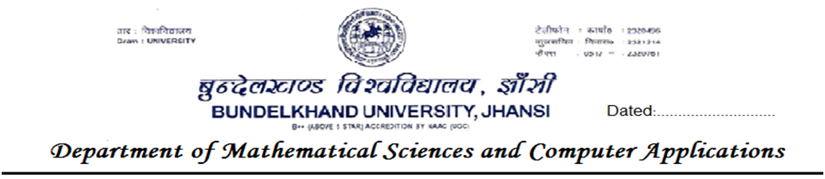

CERTIFICATE

This is to certify that work embodied in the Project entitled “Electronic Commerce Website - RatCat”, has been carried out by Mr Nitesh Sahu at Bundelkhand University, Jhansi from date 01/05/2022 to 31/07/2022.

Head of Department

(Dr. R. K. SAINI)

The MCA Viva-Voce examination of Mr. Nitesh Sahu has been held on 06/08/2022.

Signature of
Supervisor External Examiner

…………… …………………..
CANDIDATE’S DECLERATION

I hereby declared that the work being presented in this project entitled “Electronic Commerce Website - RatCat”, for partial fulfilment of the requirement to award a degree of “Master of Computer Applications” is an authentic records of my own work carried out under the supervision of Dr. Anil Kewat.
The matter embodied in this project has not been submitted by me for the award of any other degree/diploma elsewhere.

(Mr. Nitesh Sahu)

Dedicated To

My Beloved Parents

ACKNOWLEGEMENT

In carving of this thesis, I owe my deepest gratitude to my supervisor Dr. Anil Kewat, Department of Mathematical Sciences and Computer Applications, Bundelkhand University, Jhansi without whose willing co-operation and encouragement, the work would have been a fruitless venture.

I express my deep thanks to the faculty members and Dr. R K Saini, HOD of the department for his cooperation and support. I also express my thanks to Dr. Anil Kewat, Dr. Dharmendra Kumar Kanchan, and Dr. Saurabh Shrivastava etc. for their valuable suggestions.

I found no words to express my hearty feeling towards my parents Mr. Umashankar Sahu and Mrs. Urmila Sahu and my brother Devendra Sahu and my sister Shalini Sahu providing me all kind of help which gave me encouragement and to complete this project.

Candidate
Table of Contents
Abstract 8
Introduction 9
Overview 9
Statement of the problem 10
The solution 10
Objectives 11
Scope and Limitation 12
System Analysis 13
Feasibility Study 13
Requirements Analysis and Specification 16
Functional Requirements 17
Non-functional Requirements 19
System Specifications 19
System Design 20
Use-case Diagram 21
Activity Diagrams 22
DFD diagram 25
Process Flow 28
Data Flow Diagrams 29
Flow Chart 30
UML Diagram 31
Database Tables 32
Data Relationships 33
Technology used for developing the Software 34
Screenshot of the Website 36
Home 36
Product 36
Customer Registration 37
Login 38
Profile 38
Address 39
Shopping Cart 39
Checkout 40
Payment 40
Order status 41
Admin Dasboard 41
Order placed 42
Change Status of Placed Order 42
All Products 43
Add Product 43
Structure of the Project Files 44
CONCLUSION AND RECOMMENDATION 49
LIST OF ABBREVIATIONS 50

Abstract

Electronic Commerce is process of doing business through computer networks. In today’s fast-changing business environment, it’s extremely important to be able to respond to client needs in the most effective and timely manner If your customers wish to see your business online and have instant access to your products or services.

Online Shopping is a lifestyle e-commerce web application, which retails various fashion and lifestyle products. This project allows viewing various products available enables registered users to purchase desired products instantly using PayPal payment processor. This project provides an easy access to Administrators and Managers to view orders placed using Instant Pay options.

In order to develop an e-commerce website, a number of Technologies must be studied and understood. These include multi-tiered architecture, server and client side scripting techniques, implementation technologies such as Django, programming language (such as Python) and relational databases. This is a project with the objective to develop a basic website where a consumer is provided with a shopping cart application and also to know about the technologies used to develop such an application.

This document will discuss each of the underlying technologies to create and implement an ecommerce website.

Introduction

Overview

An E-commerce website requires appropriate strategy of successful design and implementation. Everything is required to plan from scratch to end of website. The e-commerce sector is seen the exponential growth thus a new option will easily part of this regatta of commercial website. The e-commerce website will feature the online shopping facility of various fashion products under a single web space. The proposed web application will allow business personnel to make their total business using it and increase their reachability thousands of times more than today they have, over the internet.

To formulate this project first task is to do is cost estimation. For probabilistic assessment of the project cost estimation is required. Cost estimation covers the accurate estimations of cost and effort required for the project.

The available resources of a company are also affecting the cost estimation. It will be very complex project. To demonstrate knowledge learnt in class, tech communities and online materials, I will undertake the entire project alone even though it requires a team of 6 or more. It will take time of 3 months to get the shape or get the basic structure. The environment variants depend on the further requirements of the ecommerce web application.

This project is mainly divided into two main categories: The Administrators and the Customers/Users. The store manager and the staff members operate as the administrators. They can add, edit, update products or delete products thus they able to change the names of products, change prices and add or remove products. The customer can search for products selection, update the cart, remove products from the cart and check out from the shop. The customer is also able to update his information such as names, address and other data. The User is only able to browse the online shop and add a product to the cart. The user is limited to the use of the shop.

Statement of the problem

Traditionally, customers are used to buying the products at the real, in other words, factual shops or supermarkets. It needs the customers to show up in the shops in person, and walk around different shopping shelves, and it also needs the owners of shops to stock, exhibit, and transfer the products required by customers. It takes labor, time and space to process these operations Furthermore, the spread of the Covid-19 pandemic has caused a lot of changes in our lifestyle, people fearing to get outside their homes, transportation almost shut down and social distancing becoming all the more important. Big to small scale business that relied on the traditional incur a lot of consequence due to the lockdown issues. Some tend to more towards using social media platforms like Facebook to sell their product. However, the social media platforms have been beneficial for marketing purposes alone but leaves the whole task of customer and massive order management via direct messaging (DM), which takes a lot of time to respond to all customers. In addition, everyone tends to use social media, posing a great challenge to differentiate between scammers (fraudsters) and legit sellers.

The solution

RatCat E-Commerce is an online shopping system provides a solution to reduce and optimize these expenses. Authorized Customers do not need to go to the factual shops to choose, and bring the products they need by hands. They simply browse their Personal computers or cell phones to access shops, and evaluate the products description, pictures on the screen to choose products. In addition, the owners of the shop do not need to arrange or exhibit their stocks products. They just input the description, prices of products, and upload their pictures. Simply, both customers and shop owners do not need to touch the real products in the whole process of shopping, and management. In the end the logistic center will distribute the products required by customers, or products ordered by shop owners to their locations. The customers are able to track the status of their orders until delivery, after which they can leave a review of the type of service they received. The payment and products’ quantity will be saved in database through the data flow. These shopping, management and distribution processes greatly simplify and optimize the retail business.

Objectives

The main objective of the study is to develop an online e-commerce system. The system aims to achieve the following objectives:

- To design an online e-commerce system.

- To provides a solution to reduce and optimize the expenses of customer order management.

- To create an avenue where people can shop for fashion products online.

- To develop a database to store information on fashion products and services.

Scope and Limitation

Every project is done to achieve a set of goals with some conditions keeping in mind that it should be easy to use, feasible and user friendly. As the goal of this project is to develop an e-commerce system, this system will be designed keeping in mind the conditions (easy to use, feasibility and user friendly) stated above. It may help in effective and efficient order management. In every shot time, the collection will be obvious, simple and sensible. It is very possible to observe the customer potentials and purchase patterns because all the ordering history is store in the database. It is efficient managing all the operations of an online store within a single platform. The project aims to automate the business process of RatCat Fashion store.

On the contrary, designing web applications is characterized by some constraints and limitations. Developers are limited to a small set of graphical widgets for use in presenting a user interface. Web-based applications require high investment in software, as well as maintenance costs for the software and personnel for software administration. In this study, verification of credentials for membership cannot be done. Besides, there is a payment page although just for demo.
Customers are advised to fill in pseudo details (DONT FILL YOUR ORIGINAL CARD DETAILS THERE). By the way, website do not save these details.

System Analysis

Analysis is an important part of any project; if analysis is not done properly then whole project move in the wrong direction. It also provides a schedule for proper project work. Analysis task divided into 3 areas:

- Problem Recognition.
- Feasibility Study.
- Requirement Analysis.

Feasibility Study

Feasibility study of the system is a very important stage during system design. Feasibility study is a test of a system proposal according to its workability impact on the organization, ability to meet user needs, and effective use of resources. Feasibility study decides whether the system is properly developed or not. There are five types of feasibility as mentioned below:

- Technical Feasibility
- Time Schedule feasibility
- Operational feasibility
- Implementation feasibility
- Economic Feasibility

Technical Feasibility

Technical feasibility corresponds to determination of whether it is technically feasible to develop the software. Here those tools are considered, which will be required for developing the project. The tools, which are available, and tools, which will be required, are taken into account. Considering all above points and aspects it is observed that the cost incurred in developing this project from a technical perspective would not be too high. Thus, it is feasible for company as well as for me to develop this system.

Time Feasibility

Time feasibility corresponds to whether sufficient time is available to complete the project. Parameters considered:

- Schedule of the project.
- Time by which the project has to be completed.
- Reporting period

Considering all the above factors it was decided that the allotted time that is 3 months was sufficient to complete the project.

Operational Feasibility

Operational feasibility corresponds to whether users are aware of interface environment and sufficient resources are available or not. Parameters considered:

- People with a basic knowledge of computers would be able to use our system very effectively and easily, as the system would have an intuitive GUI. The director and employees of RatCat Fashions have a basic operating knowledge of computers, so understanding the working of the system and using it would be easy from the decision maker’s point of view.

- All the relevant necessary resources for implementing and operating this system are already present in office.

Bearing in mind the above factor, it was observed that the cost would be incurred in developing this project from an operational standpoint would be low. Thus, it would be operational feasible for the company.

Implementation Feasibility

Implementation Feasibility is about basic infrastructure required to develop the system. Considering all below points, it is feasible to develop system. Factors considered:
- All the minimum infrastructure facility required like PC, books, technical manuals are provided.
- Proper guidance is provided.
- All necessary data and files are provided.

Economic Feasibility

Economic Feasibility is about total cost incurred for the system. The software resource requirement of the proposed system is Django and SQLite for functional and backend development and html, css, js for the frontend ui.

Requirements Analysis and Specification

A complete understanding of software requirement is essential to the success of a web- development effort. No matter how well designed or well coded, a poorly analyzed and specific program will disappoint user and bring grief to the developers.

The requirement analysis task is process of discovery, refinement, modified and specification. The software scope, initially established by the system engineer and refined during project planning, is refined in detail. Models of the required data, information and control flow, and operational behaviour are created. Alternative solutions are analysed and various project element.

Requirements Gathering

Also known as data collection. Data Collection is an important aspect of any type of research study. Inaccurate data collection can impact the results of a study and ultimately lead to invalid results. The methods used to gather the projects requirements involves Quantitative research to review the existing systems in the market.

Requirements

The requirements from the proposed system was categorized into functional and non- functional requirements.

Functional Requirements

The following is the desired functionality of the new system. The proposed project would cover:

Customer Module

- Customer can view/search products without login.

- Customer can also add/remove product to cart without login (if customer try to add same product in cart. It will add only one)

- After creating account and login to system, he/she can place order.

- If customer click on pay button, then their payment will be successful and their order will be placed.

- Customer can check their ordered details by clicking on orders button.

- Customer can see the order status (Pending, Confirmed, Delivered) for each order

- Customer can Download their order invoice for each order

Admin Module

- Admin can provide username, password and login to the admin panel.

- After login, there is a dashboard where admin can see how many customers is registered, how many products are there for sale, how many orders placed.

- Admin can add/delete/view/edit the products.

- Admin can view/edit/delete customer details.

- Admin can view/delete orders.

- Admin can change status of order (order is pending, confirmed, out for delivery, delivered)

Additionally, if customer places order and admin deleted that user (fraud detection), then their orders will automatically be deleted. Suppose one (1) customer places four (4) products order and admin deleted two (2) product from website, then that two-product order will also be deleted and other two will be there. Also, if user click on purchase button without having products in their cart, then website will ask to add product in cart first.

Non-functional Requirements

It specifies the quality attribute of a software system. They judge the software system based on Responsiveness, Usability, Security, Portability and other non-functional standards that are critical to the success of the software system.

Availability: The system should remain operational in any day and any place.
Accuracy: There is a need to optimize the system to ensure more accurate results and calculations.
Usability: The system should provide a User-friendly user interface and tooltips to enhance itself and be effectively responsive.
Secure: The system must be able to provide security against any external injections by using a layered security system. Implementation of user login functionalities also ensures the system is secure from unauthorized persons.
Performance of the system: Response time is very good for given piece of work. The system will support multi user environment.
Reliability of the system: The system will be highly reliable and it generates all the updates information in correct order. Data validation and verification is done at every stage of activity. System recovery will also be speed.

System Specifications

This section describes the hardware components and software requirements needed for effective and efficient running of the system.

Hardware Requirements
Sr. No. | Hardware | Minimum System Requirement
01 | Processor | 2.4 GHz Processor speed
02 | Memory | 2 GB RAM
03 | Disk Space | 500 GB

Software Requirements
Sr. No. | Software | Minimum System Requirement
01 | Operating System | Windows 7, Windows 10 or MAC OS 10.8,10.9, or 10.11, LINUX
02 | Database Management System | SQL Lite 3
03 | Runtime Environment | Visual Studio Code or PyCharm

System Design

This section describes the system study, analysis, design strengths and weaknesses of the current system, Contest level diagrams, Entity Relationship Diagram, Architectural design. After interpretation of the data, tables were drawn and process of data determined to guide the researcher of the implementation stage of the project. The tools, which were employed during this methodology stage, where mainly tables, Data Flow Diagrams and Entity Relationship Diagrams. The design ensures that only allows authorized users to access the systems information.

Use-case Diagram

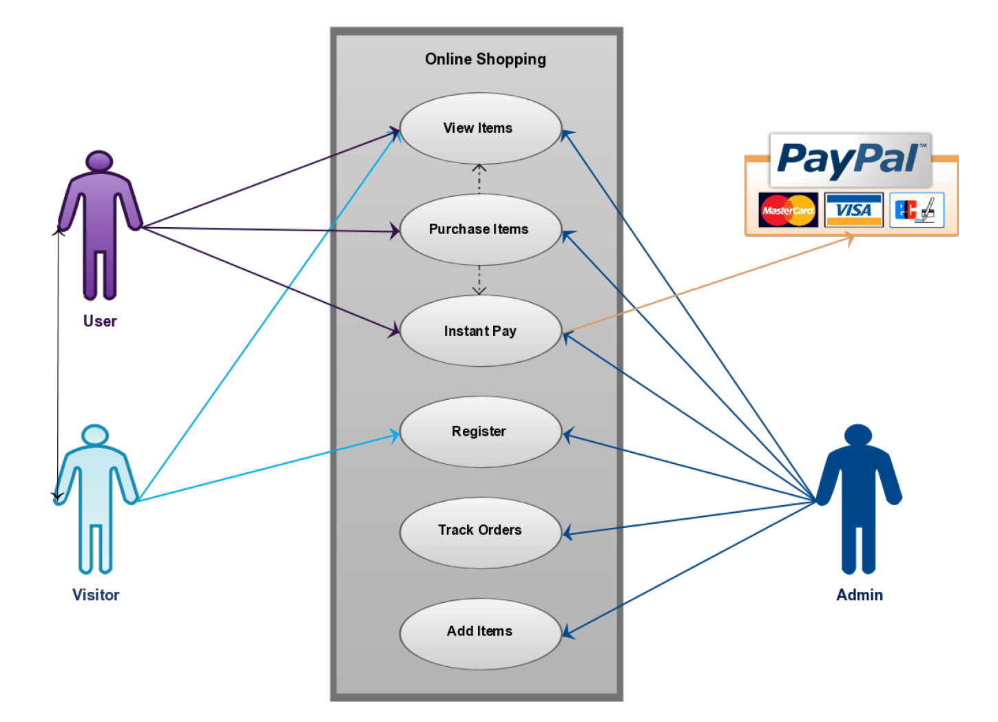

Activity Diagrams

Login Activity
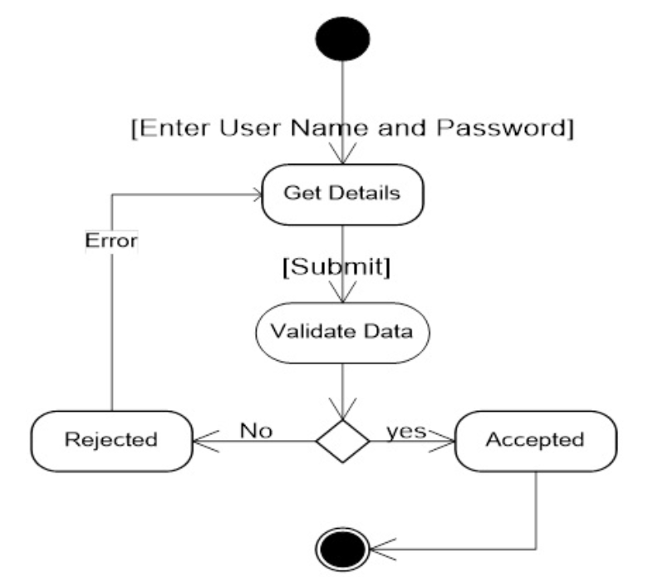

Registration Activity Diagram:
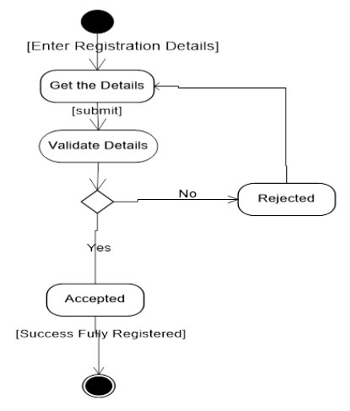
Admin Activity Diagram:
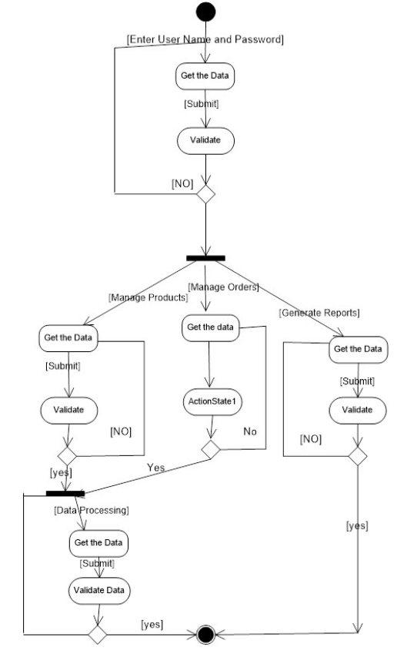

User Activity Diagram:
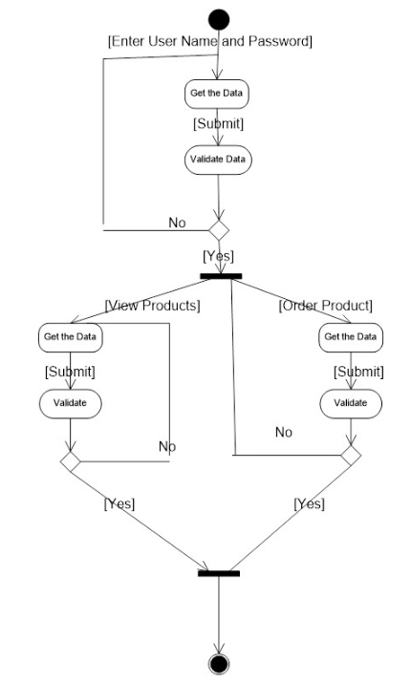

DFD diagram

Context Level (0th Level) Diagram:

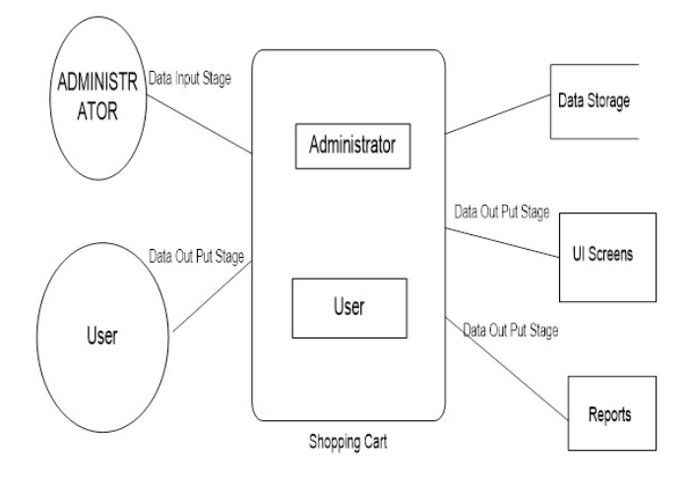
Login DFD
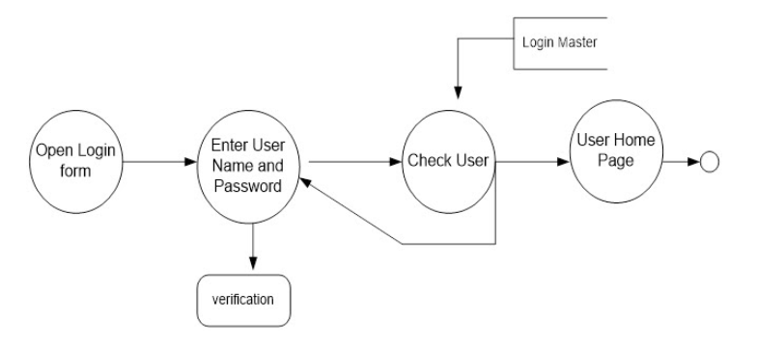

1st Level DFD Diagram
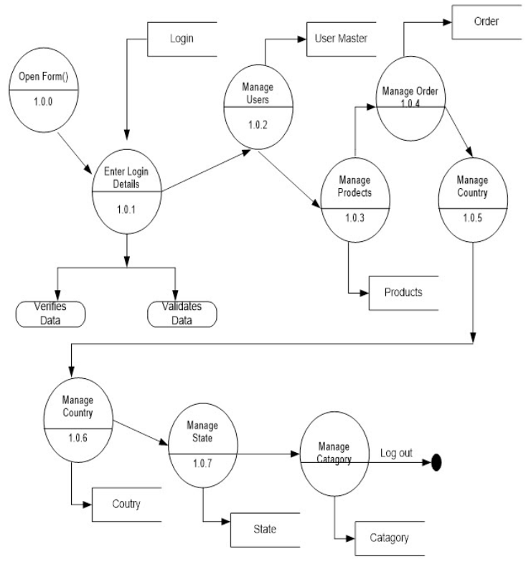
2nd Level DFD For Manage Product
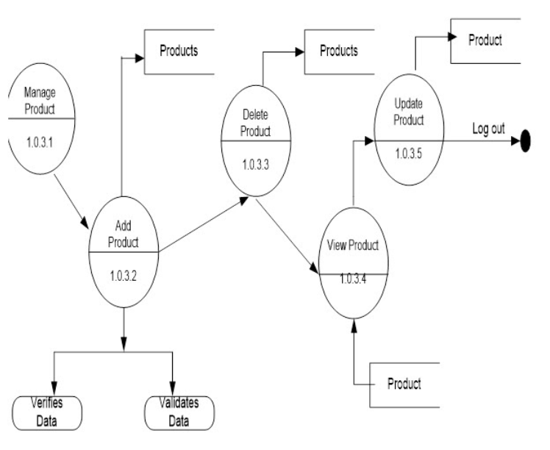’

2nd Level DFD For Manage Product
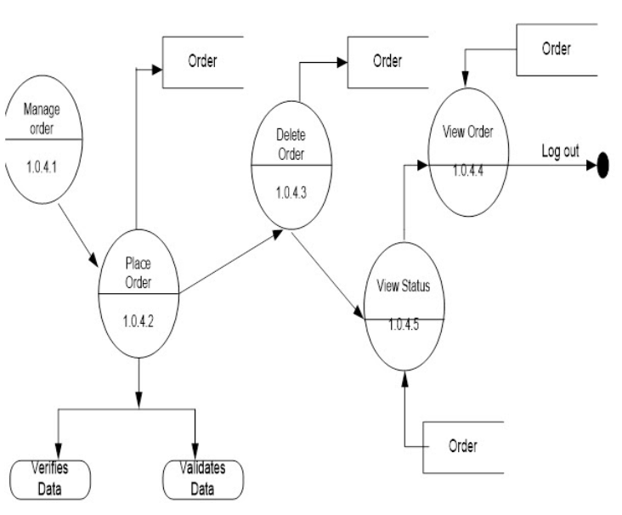

User Activities DFD
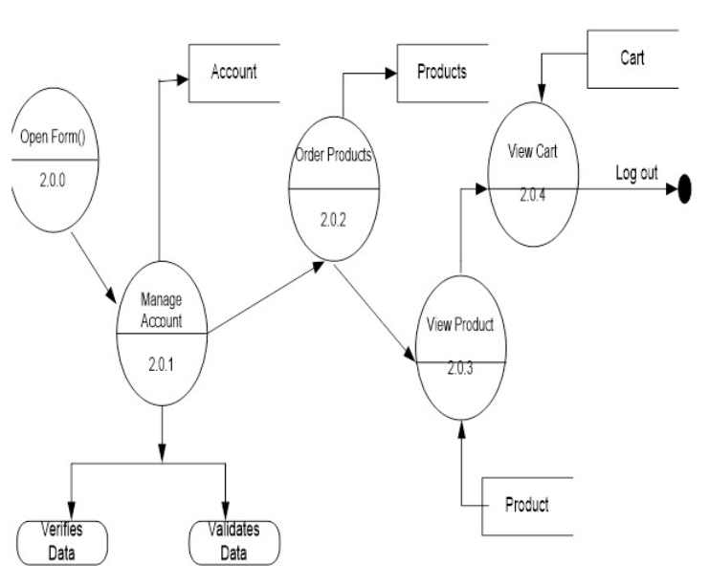

Process Flow
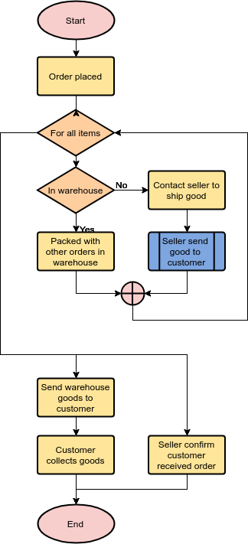

Data Flow Diagrams

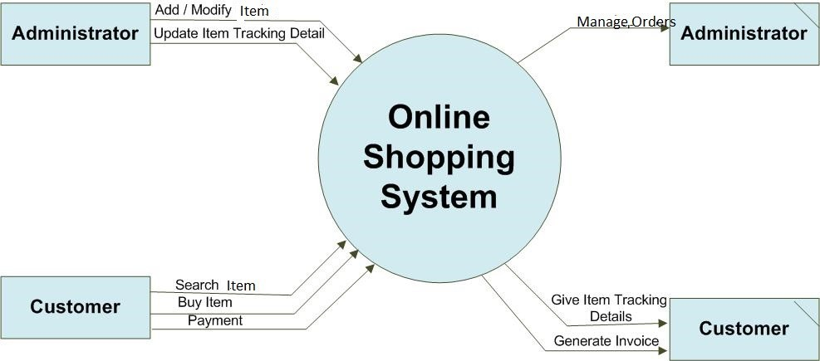

Flow Chart

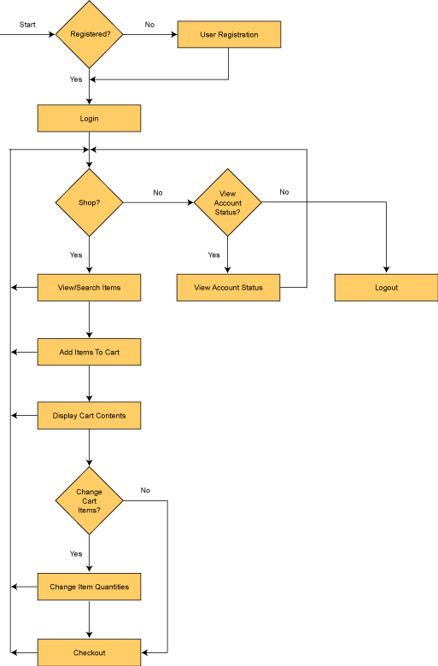

UML Diagram

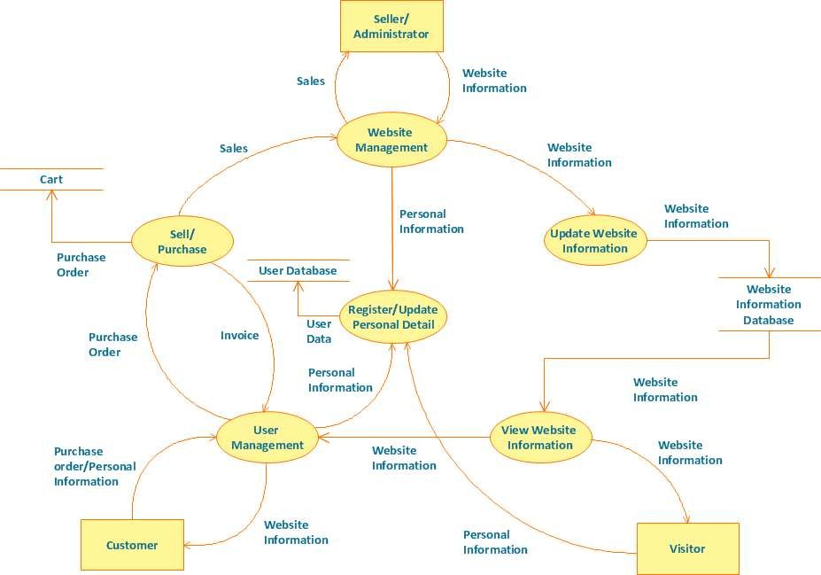

Database Tables

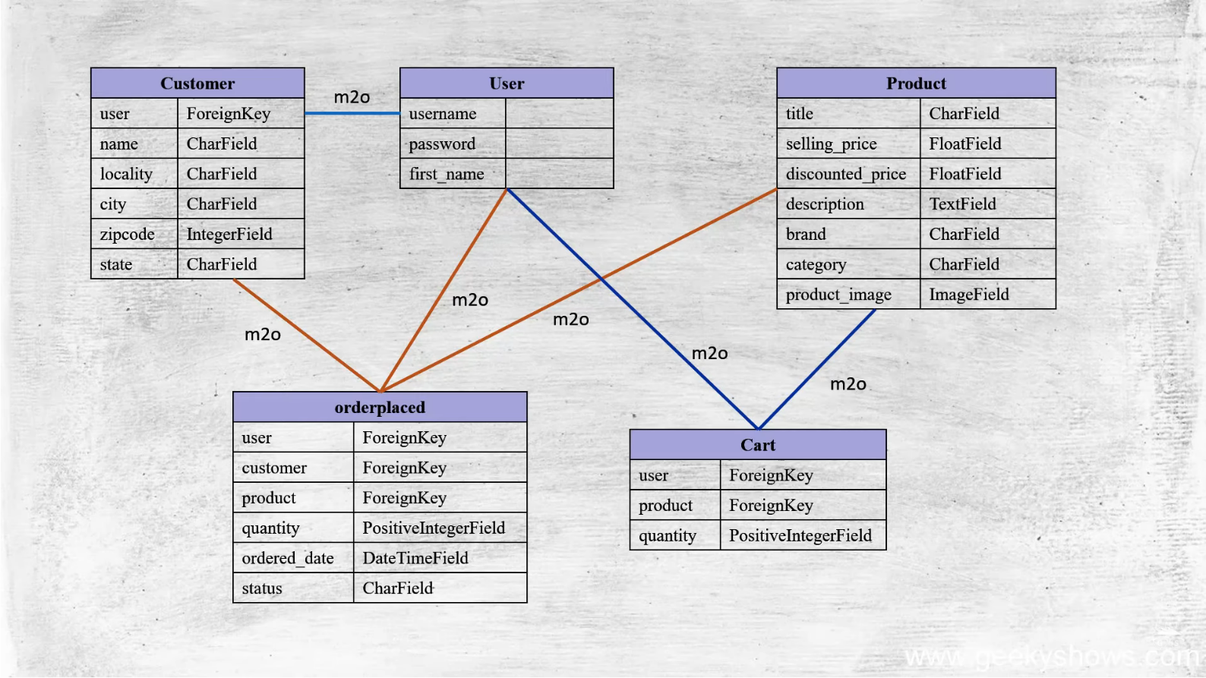

Data Relationships

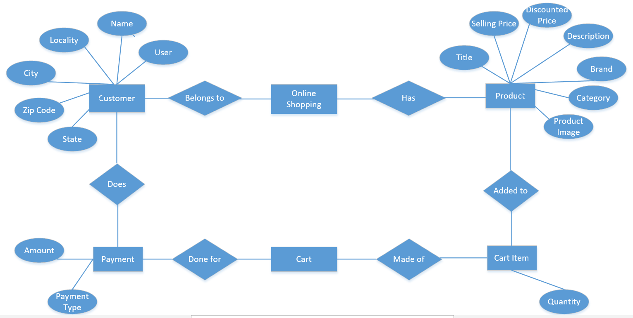

Technology used for developing the Software

Hypertext Mark-up Language (HTML)

HTML is the standard markup language for documents designed to be displayed in a web browser. HTML describes the structure of a Web page. It can be assisted by technologies such as Cascading Style Sheets (CSS) and scripting languages such as JavaScript. HTML elements are the building blocks of HTML pages. HTML elements tell the browser how to display the content.

Cascading Style Sheets (CSS)

Cascading Style Sheets (CSS) is a style sheet language used for describing the presentation of a document written in a markup language such as HTML.[ CSS is a simple mechanism for adding style (e.g., fonts, colors, spacing) to Web documents. CSS is designed to enable the separation of presentation and content, including layout, colors, and fonts
Bootstrap

Bootstrap is a free and open-source CSS framework directed at responsive, mobile-first front-end web development. It contains HTML, CSS and (optionally) JavaScript-based design templates for typography, forms, buttons, navigation, and other interface components.
JavaScript

JavaScript often abbreviated JS, is a programming language that is one of the core technologies of the World Wide Web, alongside HTML and CSS. Over 97% of websites use JavaScript on the client side for web page behavior, often incorporating third party libraries. All major web browsers have a dedicated JavaScript engine to execute the code on users' devices.
SQLite

SQLite is a software library that implements a small, fast, high-reliability, full-featured, self-contained, serverless, zero-configuration and transactional SQL database engine. SQLite is the most widely deployed SQL database engine in the world. The source code for SQLite is in the public domain.
Django

Django is an open-source web framework written in the Python programming language. Named after the jazz guitarist Django Reinhardt, it is used by some of the largest websites in the world including Instagram, Mozilla, and NASA, but also lightweight enough to be a popular choice for weekend side projects and startups. Its "batteries-included" approach means a powerful website can be generated quickly in the hands of a skilled developer.
Python

Python is a high-level, interpreted, dynamically-typed, general-purpose programming language. Its design philosophy emphasizes code readability with the use of significant indentation. It supports multiple programming paradigms, including structured (particularly procedural), object-oriented and functional programming. It is often described as a "batteries included" language due to its comprehensive standard library.

Screenshot of the Website

Home
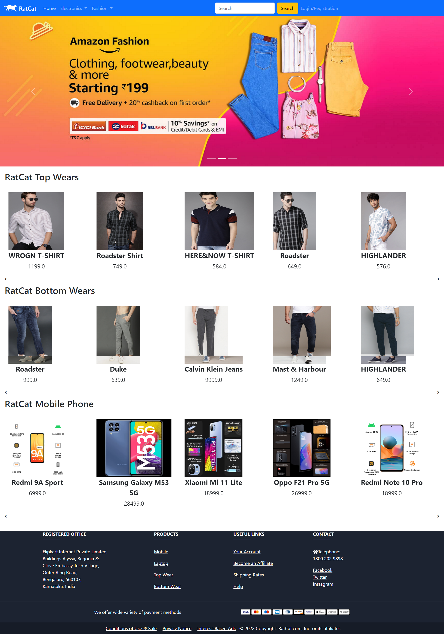

Product

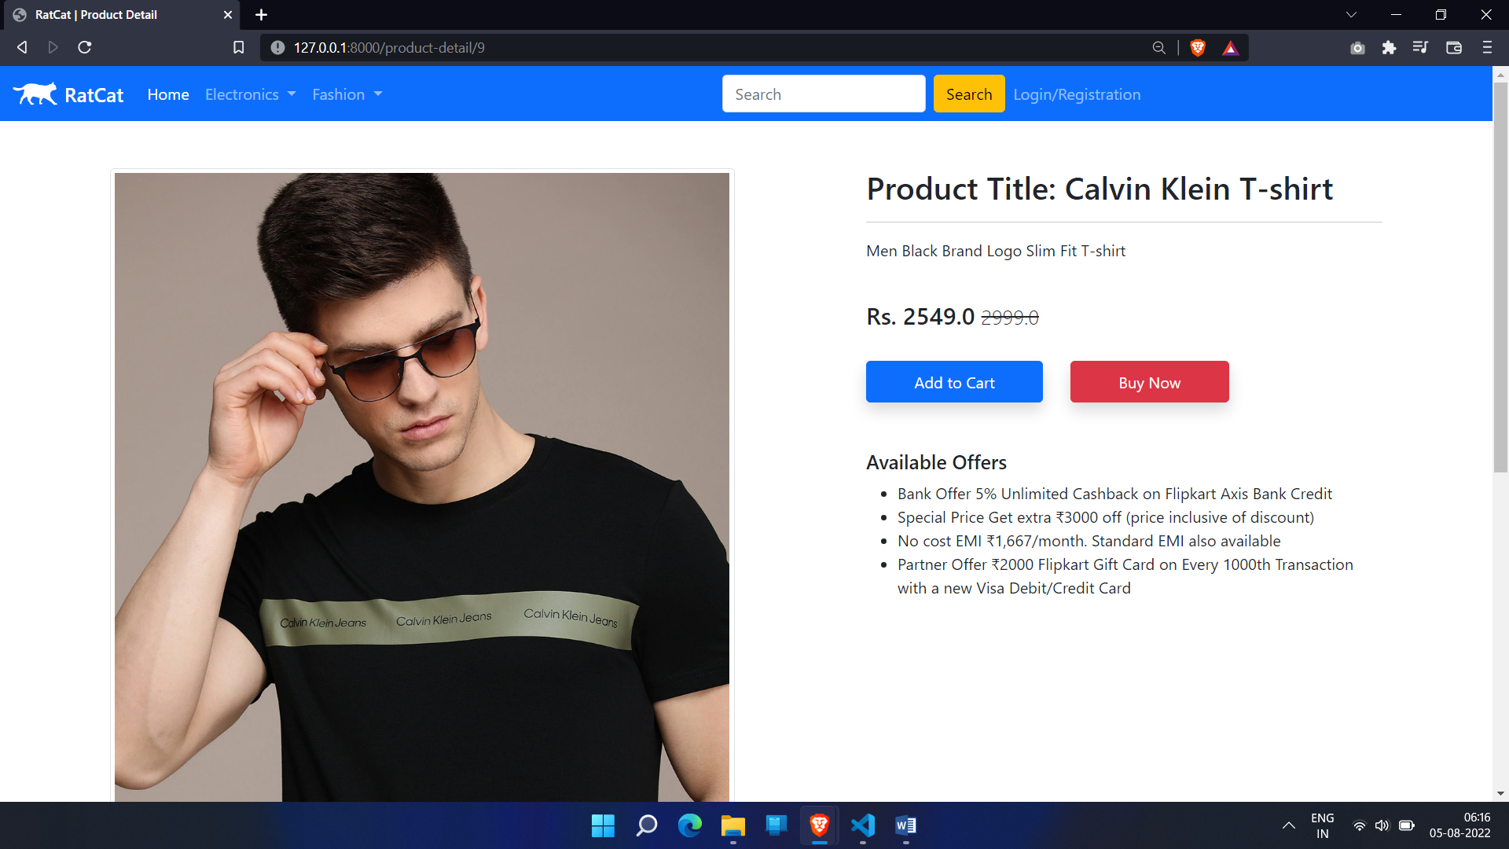

Customer Registration

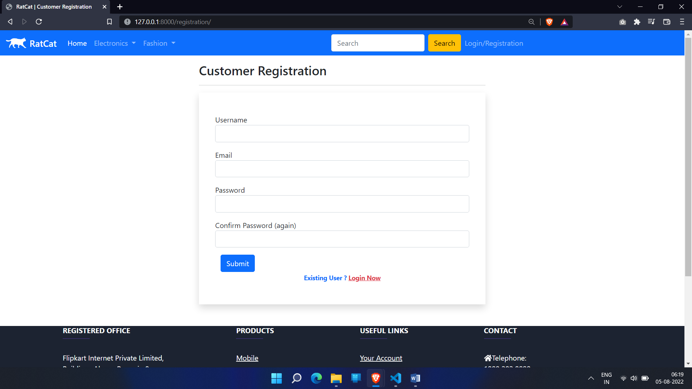

Login

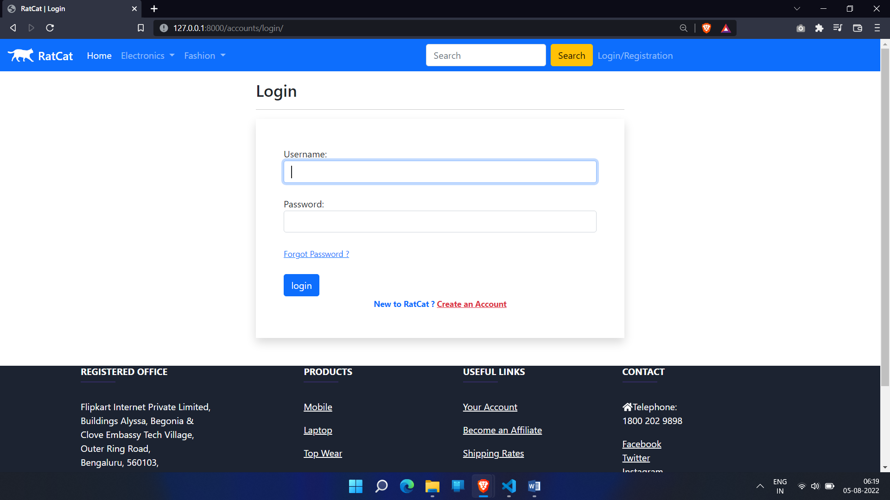

Profile

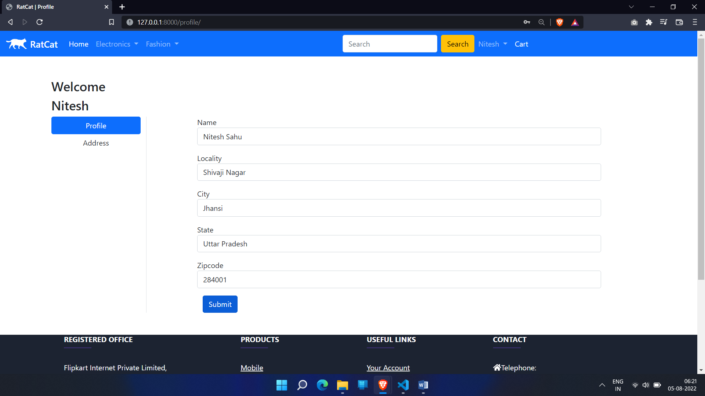

Address

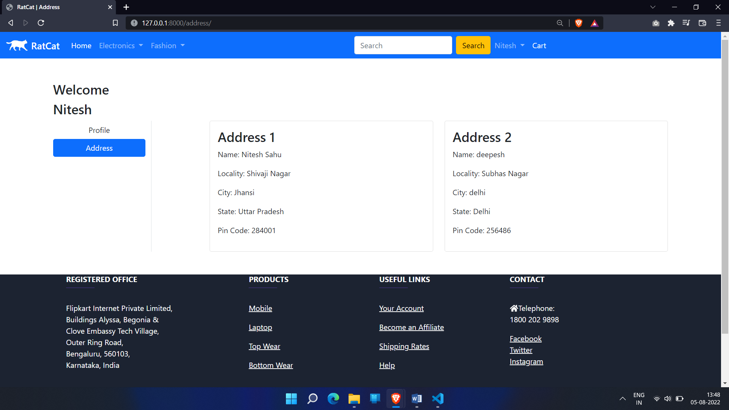

Shopping Cart

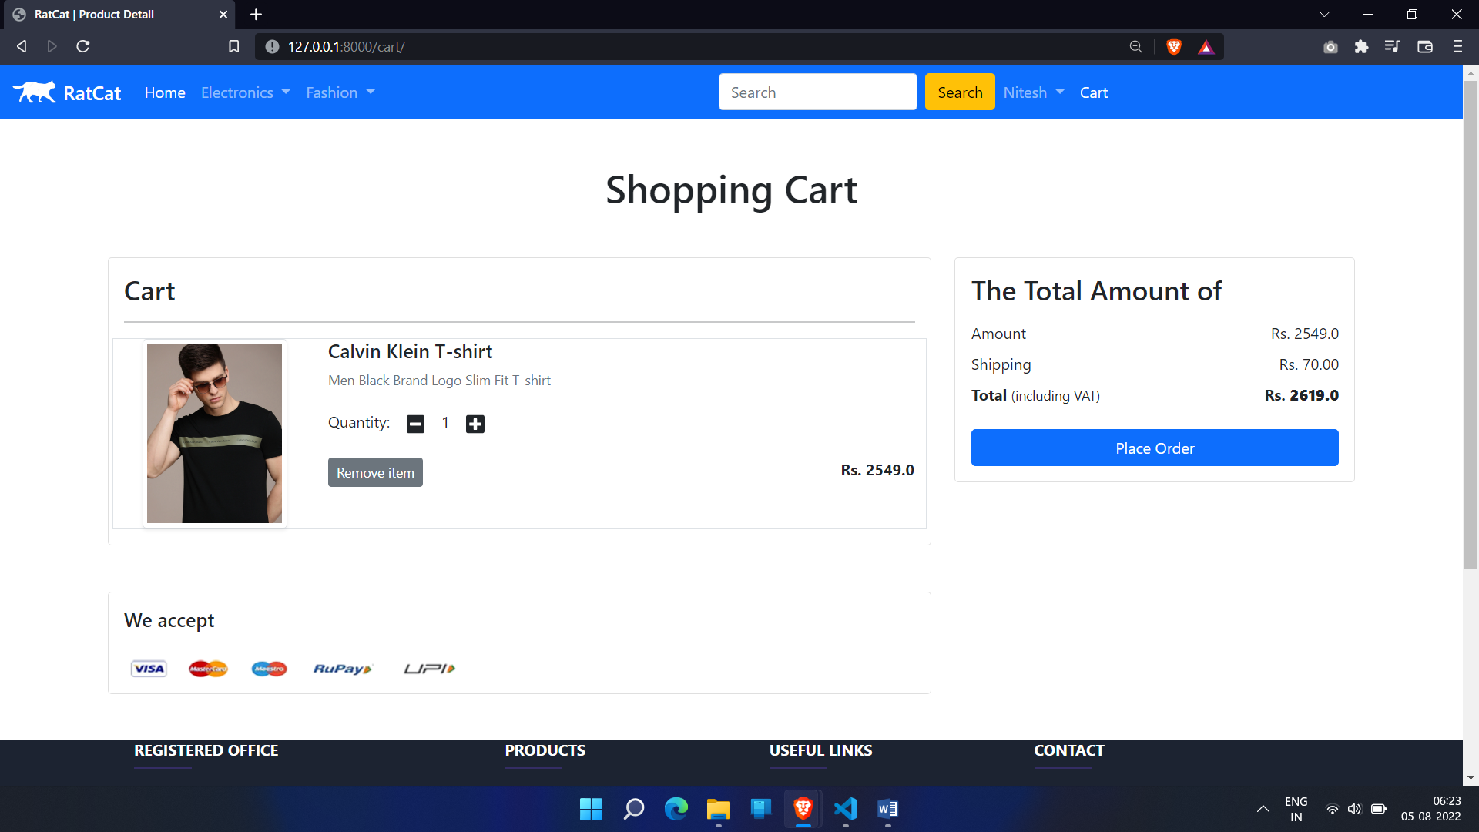

Checkout

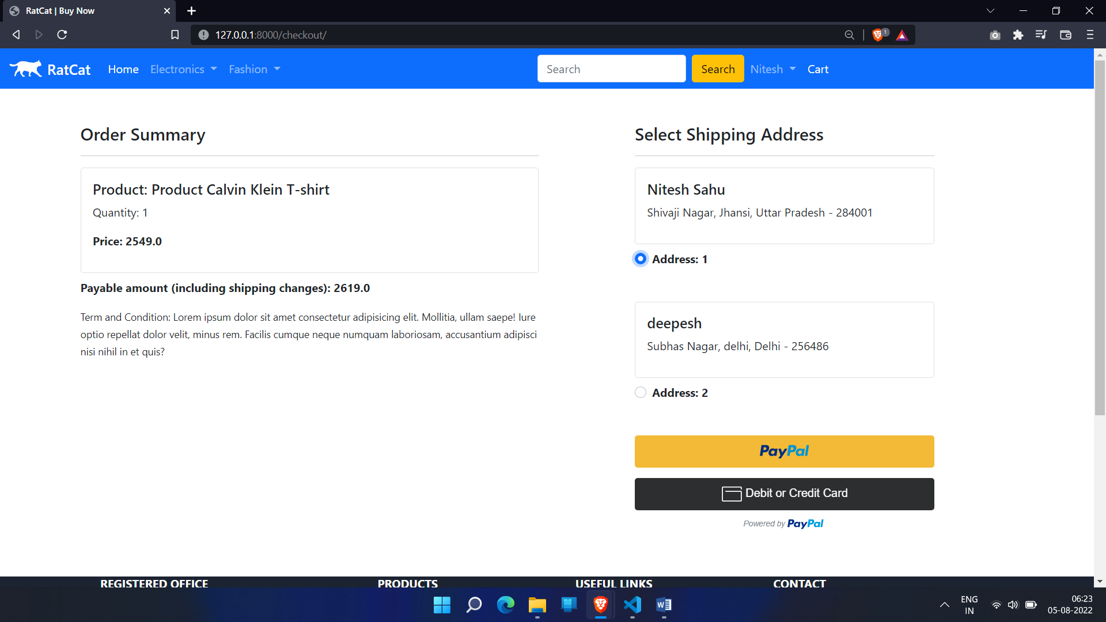

Payment

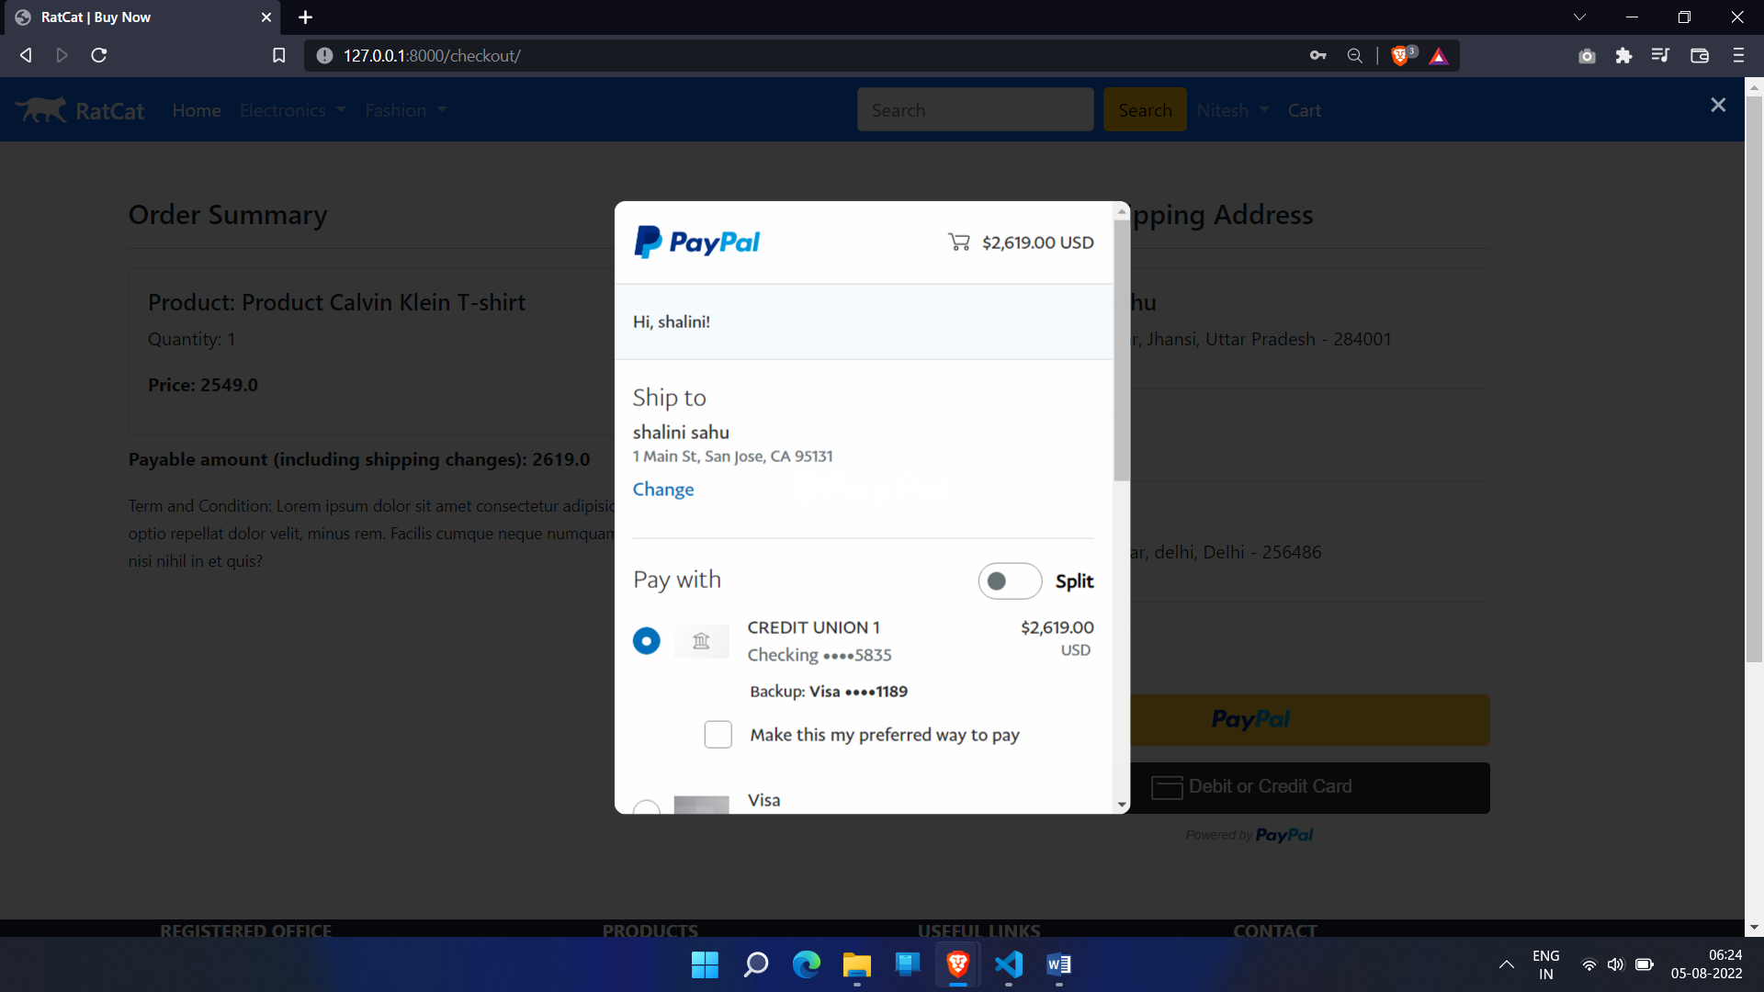

Order status

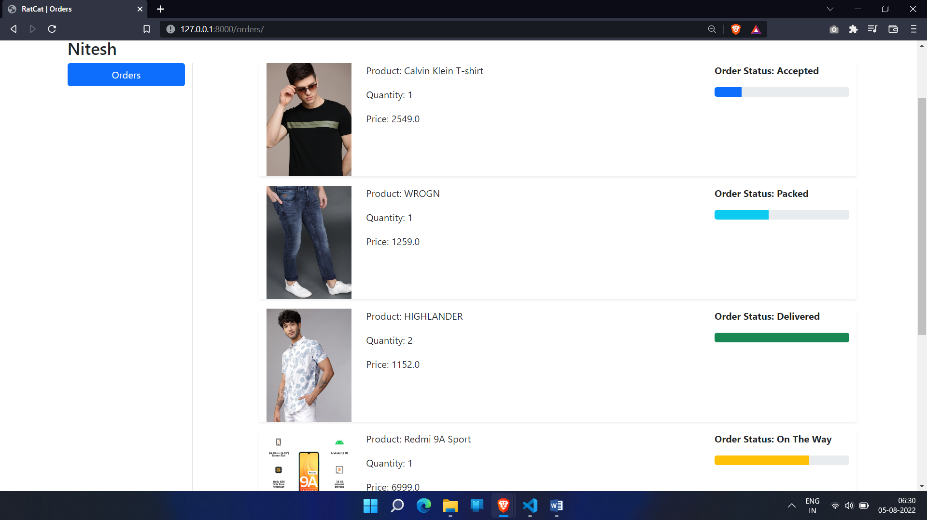

Admin Dasboard

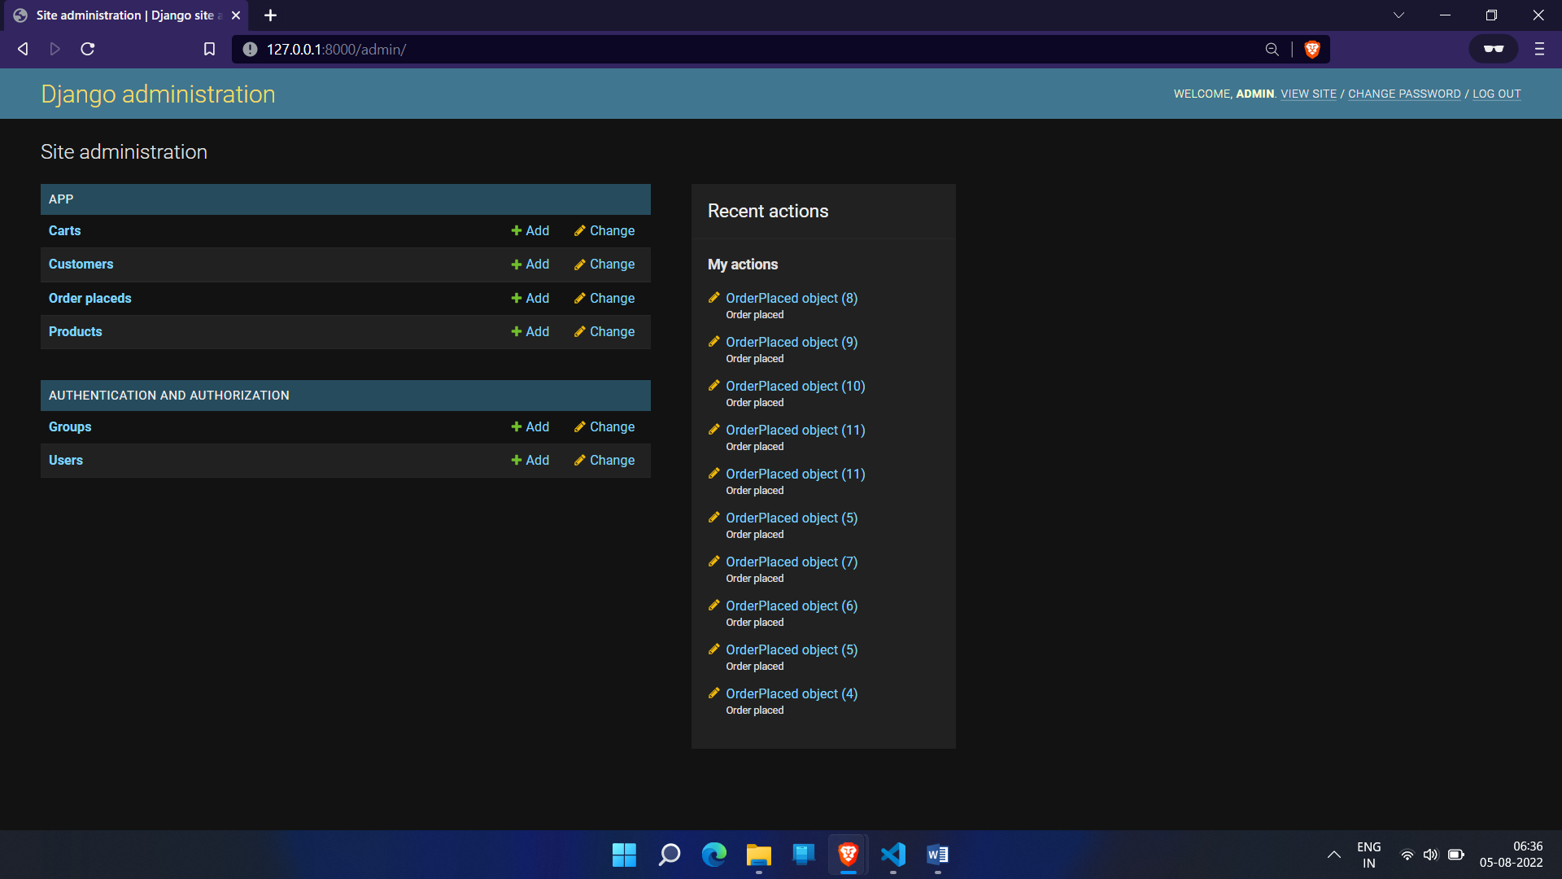

Order placed

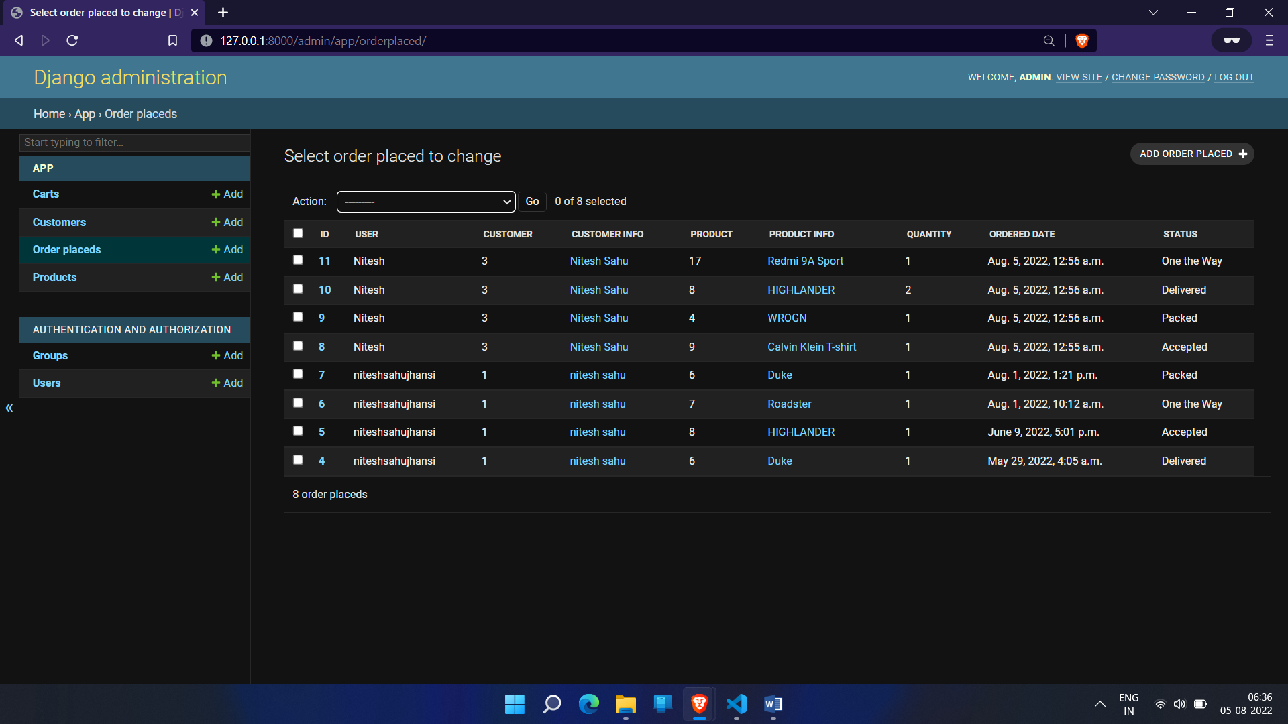

Change Status of Placed Order

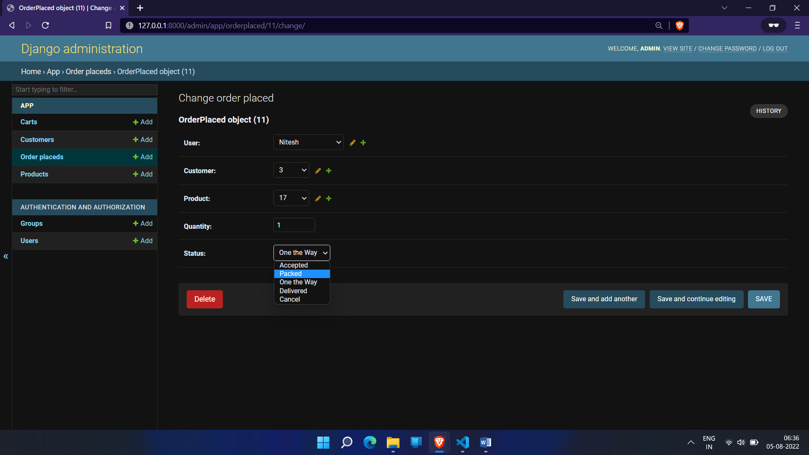

All Products

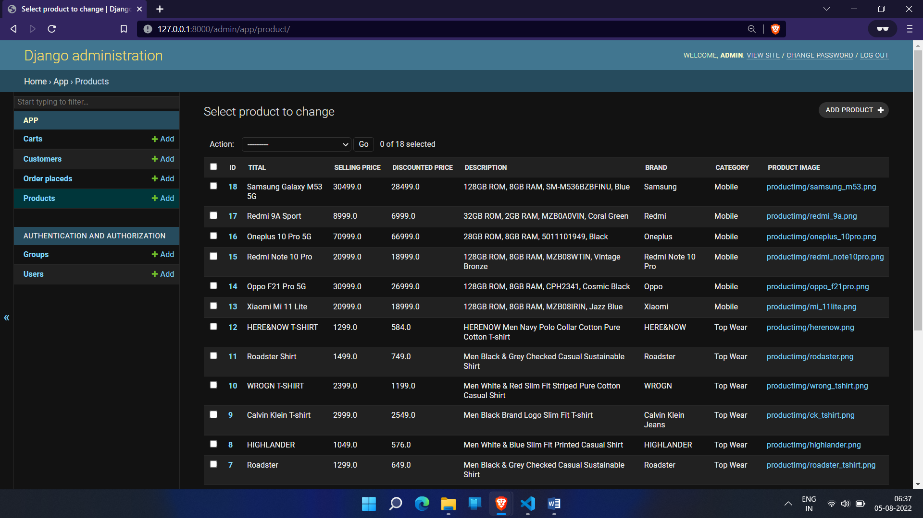

Add Product

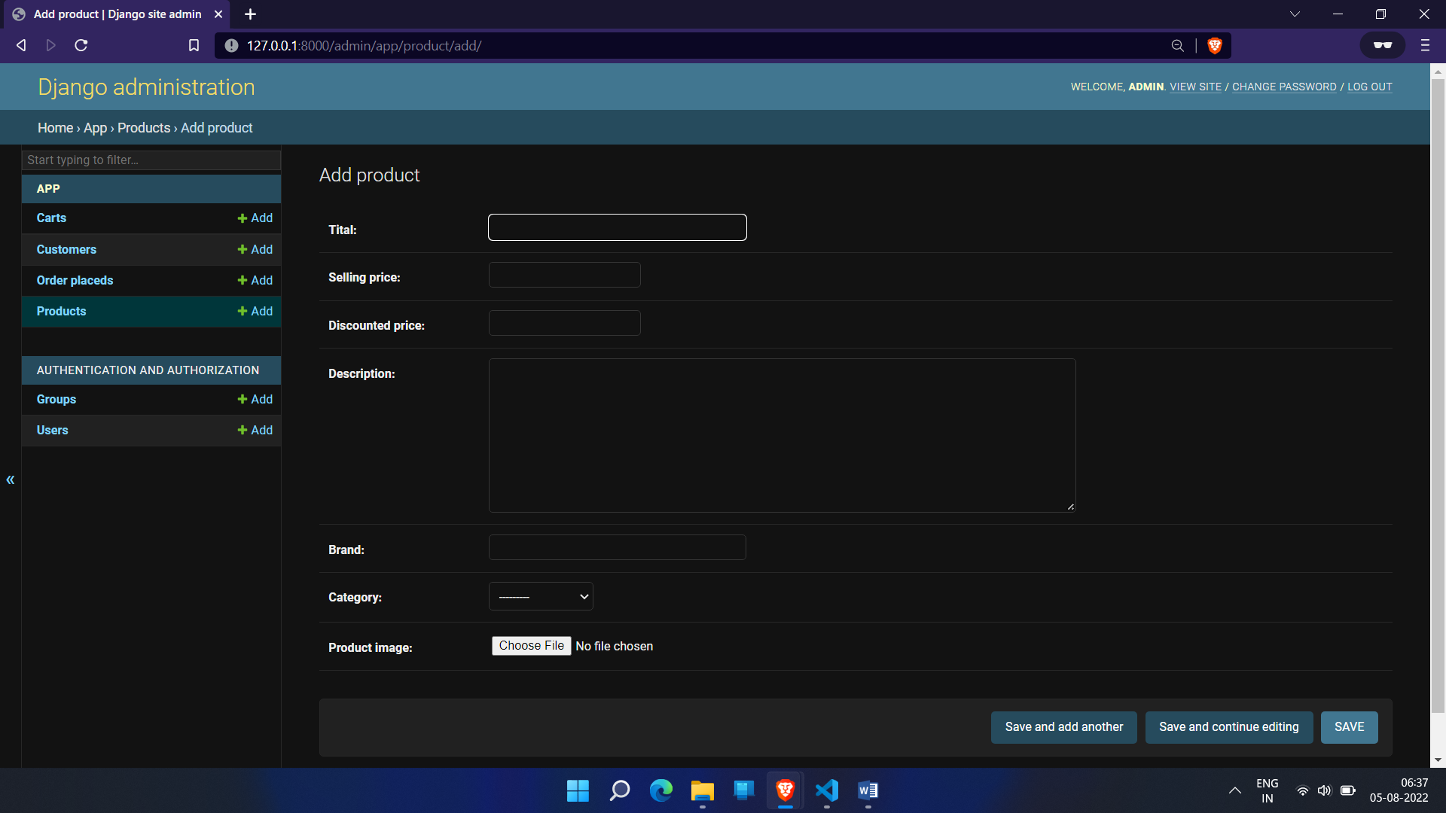

Structure of the Project Files

Model View Controller or MVC as it is popularly called, is a software design pattern for developing web applications. A Model View Controller pattern is made up of the following three parts:

- Model - The lowest level of the pattern which is responsible for maintaining data.
- View – This is responsible for displaying all or a portion of the data to the user.
- Controller - Software Code that controls the interactions between the Model and View.

MVC is popular as it isolates the application logic from the user interface layer and supports separation of concerns. Here the Controller receives all requests for the application and then works with the Model to prepare any data needed by the View. The View then uses the data prepared by the Controller to generate a final presentable response. The MVC abstraction can be graphically represented as follows.

MVC (Model View Controller Flow) Diagram
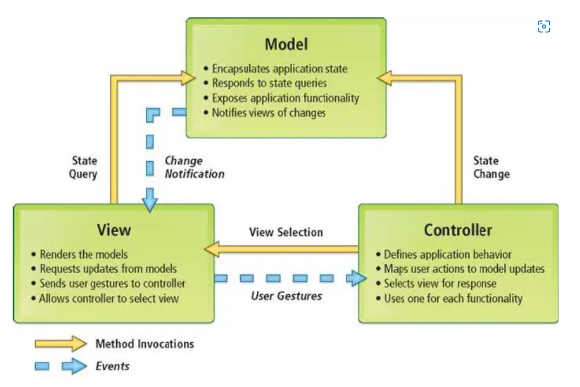
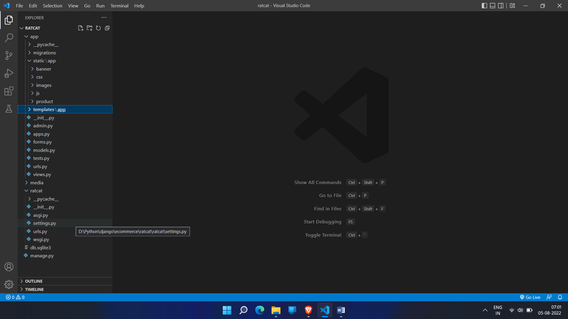

Django is a Model View Control (MVC) framework

- mange.py -This file is used basically as a command-line utility and for deploying, debugging, or running our web application. It contains code for run-server, or make migrations or migrations, etc. that we use in the shell. Anyway, we do not need to make any changes to the file.
- db.sqlite3 is the database file.

- static folder contains all the static files like CSS and images.

- ratcat folder is the Django projects consisting of init, admin, models, views, apps and forms.

- Models are basically the blueprints of the database we are using and hence contain the information regarding attributes and the fields etc of the database.

- Views is a crucial one, it contains all the Views (usually as classes). Views.py can be considered as a file that interacts with the client. Views are a user interface for what we see when we render a Django Web application.

- URLs Just like the project urls.py file, this file handles all the URLs of our web application.
- ratcat folder is the Django application directory consisting of the following essential files.
- Init.py This file remains empty and is present them only to tell that this particular directory is a package.
- Settings.py This file is present for adding all the applications and the middleware application present. Also, it has information about templates and databases. Overall, this is the main file of our Django web application.
- Urls.py This file handles all the URLs of our web application. This file has the lists of all the endpoints that we will have for our website.
- Wsgi.py This file mainly concerns with the WSGI server and is used for deploying our applications on to servers like Apache etc.
- Asgi.py In the newer versions of Django, you will also find a file named as asgi.py apart from wsgi.py. ASGI can be considered as a succeeded interface to the WSGI. ASGI, short for Asynchronous Server Gateway interface.
- Templates Folder contains all the HTML files for the project.
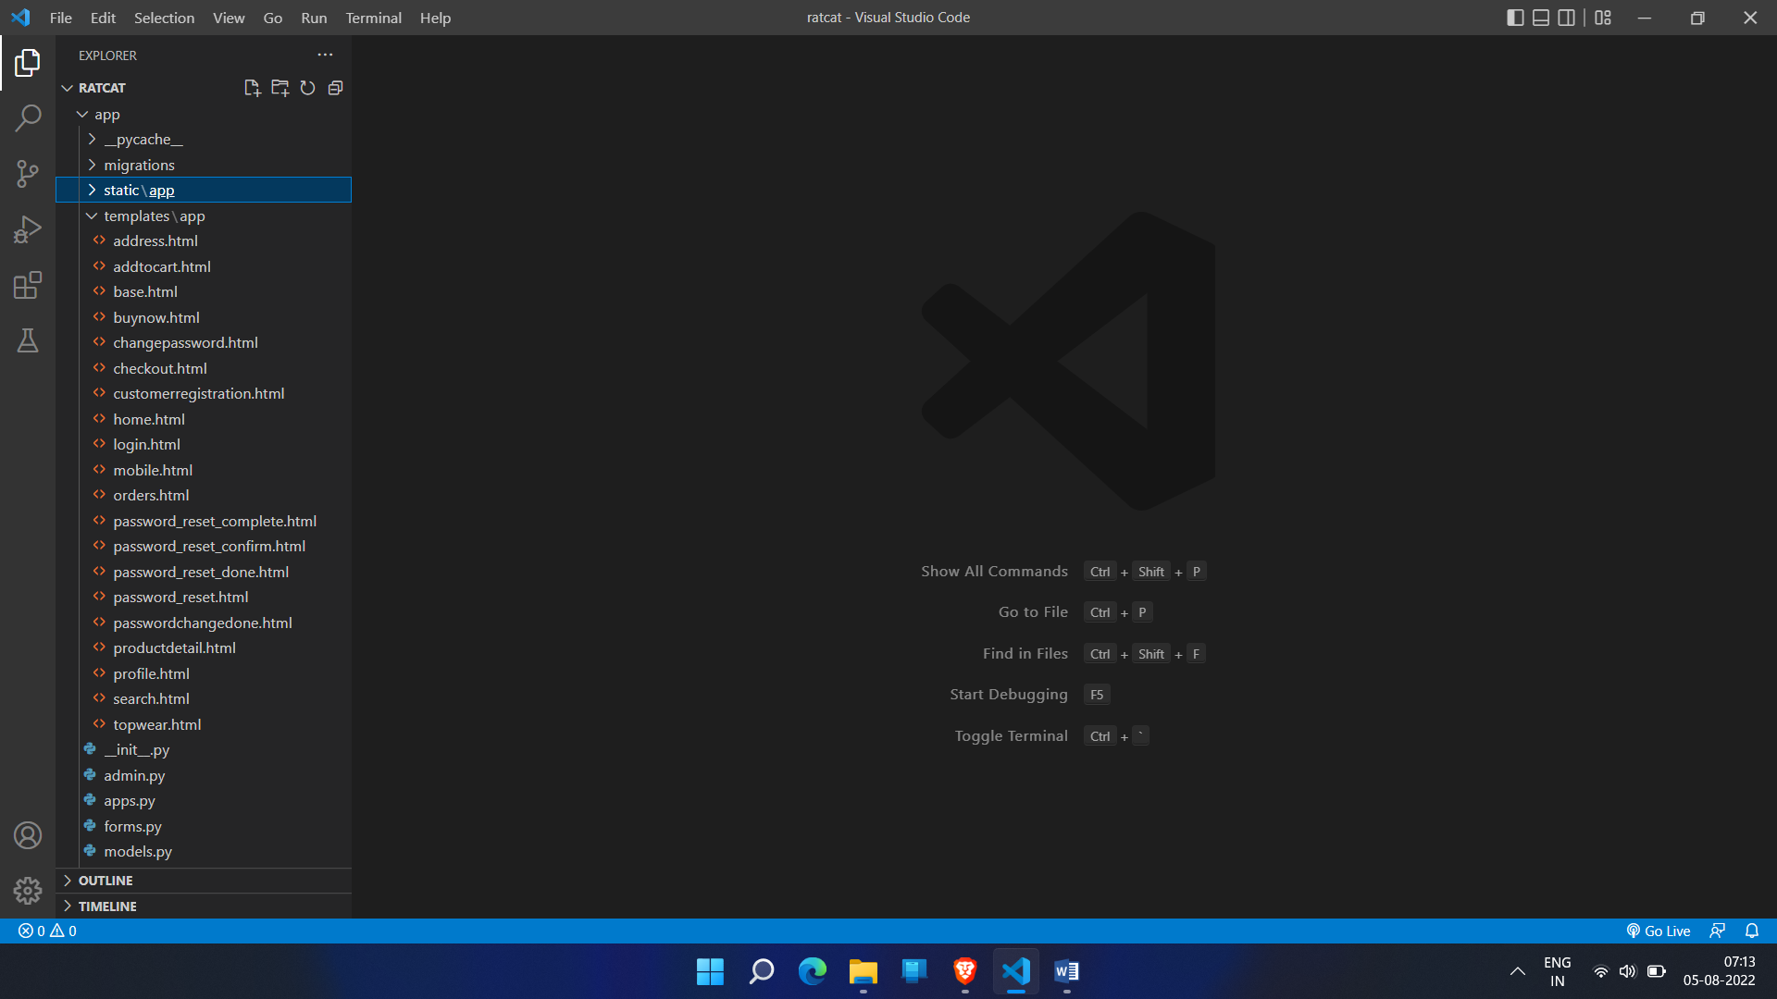

Registration | This procedure allows the customers to sign in before making an order. Managers of the website is created by system admin.
Product | This module contains the details of all products in the store.
Price | Manages Prices of products
Shopping | Manages the basic flow of orders. It’s the procedure by which a client places an order
Payment | Customer makes payment at this stage. However, this system does not have a real payment system.
Search | Customers are able to search for specific product through this procedure
Layout | Customers view products from the homepage. They can Mouse over to display product description.
Reporting | The customers are able to view and download their invoices. The system also provides room form customer feedback
Administration | The system admin / business managers access the admin dashboard that allows them to add products, view and confirm orders.

Conclusion and Recommendation

CONCLUSION

The project entitled e-commerce website RatCat was completed successfully. The system has been developed with much care and free of errors and at the same time it is efficient and less time consuming. The purpose of this project was to develop a web application for purchasing items from a fashion shop. This project enabled me gain valuable information and practical knowledge on several topics like designing web pages using html & CSS, usage of responsive templates, designing of full stack Django application, and management of database using SQLite 3. The entire system is secured. Also, the project helped me understanding about the development phases of a project and software development life cycle. I learned how to test different features of a project. This project has given me great satisfaction in having designed an application which can be implemented to any nearby shops or branded shops selling various kinds of products by simple modifications. However, it was very challenging learning and developing an application using a new technology.

RECOMMENDATION

There is a scope for further development in our project to a great extent. A number of features can be added to this system in future like providing the feature like providing classes for customers so that different offers can be given to each class. System may keep track of history of purchases of each customer and provide suggestions based on their history using Machine Learning Algorithm. These features could have been implemented if time and skills did not limit me.

List of Abbreviations

Terminology Meaning

ERD Entity Relationship Diagram

DBD Database Diagram

DFD Data Flow Diagram

HTTP Hyper Text Transfer Protocol

SQL Structure Query Language

DBMS Database Management System

IDE Integrated Development Environment

